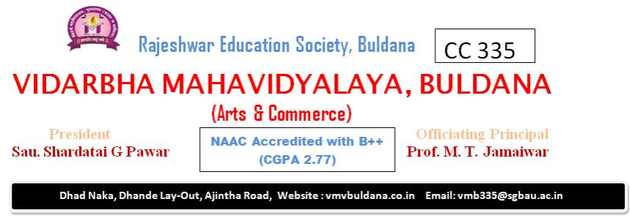

**Course Outcomes B. Com**

2. Business Communication Skill in English (AEC) BCE-11 Course Outcomes of AEC: The students will be able to:

1) The learners will learn to understand and interpret any text they are reading from

2) different perspectives

3) The interest of learners in listening to and watching good quality audio and visual media will be aroused.

4) Learners will acquire proficiency in the skills of listening, speaking, reading and writing that will help them meet the challenges of the world.

5) The learners will develop good oral and written skills of communication in the English language.

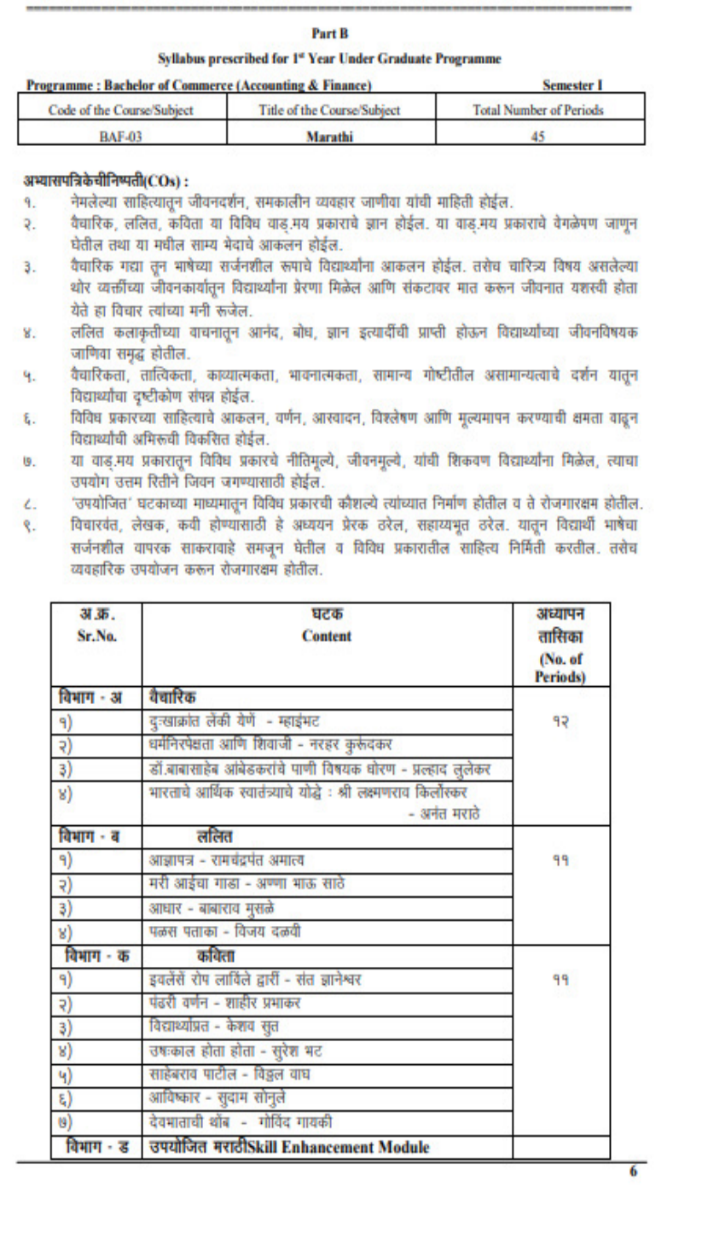

**Course Outcome**

1 Demonstrate a fundamental understanding of accounting principles and concepts, including the accounting equation, double-entry accounting, and the role of accounting in business.

2 Apply accounting principles to record and classify business transactions, prepare basic financial statements (income statement, balance sheet), and interpret financial data.

3 Analyze and evaluate the financial performance of a business by calculating and interpreting financial ratios, understanding cash flow, and identifying areas for financial improvement.

4 Comprehend ethical considerations in accounting, including the importance of accuracy, transparency, and adherence to accounting standards, and evaluate the impact of accounting on decision-making and financial reporting. U

**6. Principles of Business Management (DSC) BCE-14 CO**

**Course Outcome**

1 Understandthefundamentalprinciplesof management,including the functionsofplanning,organizing,leading,andcontrolling, andtheirapplicationinvarious organizationalsettings.

2 Analyzeand apply management theoriesandconcepts relatedto organizationalstructure, culture, anddecision-makingprocesses.

3 Demonstrate effective leadership and team management skills, including the ability tolead, motivate, and communicate withte ammemberstoachieve commongoals.

4 Comprehendtheethicalandsocialresponsibilitiesofmanagement,including ethicaldecisionmaking,corporatesocialresponsibility,andtheimpactofglobalizationonmanageme

**7. Information System BCE-15**

**CO CourseOutcome**

1 Understand the role of information systems in organizations, including the various types ofinformation systems,their components,and their impact on business processes.

2 Analyze and evaluate hardware and software components used in information systems, with an emphasis on their functionalities and how they contribute to organizational efficiency.

3 Apply database management principles and tools for data storage and retrieval, including the design,querying, and management of database to support business operations.

4 Evaluate the importance of information security,ethical considerations, and data privacy in information systems, and demonstrate an understanding of emerging technologies in the field.  Unit 1: Introduction to Information Systems

**8. Business Communication BCE-16**

**CO Course Outcome**

1 Develop effective written and oral communication skills for business contexts, including producing clear, concise, and professional business documents and presentations.

2 Apply appropriate communication techniques in various business settings, such asemails, memos, business letters, and reports, with a focus on audience analysis and purpose.

3 Demonstrate effective interpersonal communication skills, including active listening, conflict resolution, and the ability to communicate in team and group settings.

4 Understand the ethical considerations in business communication, including theimportance of maintaining professional and ethical conduct in all aspects of business

. Computer Fundamental & Operating System I (Practical) (DSC) BCE-16 Code of the Course/Subject Title of the Course/Subject Total Number of Periods BC-16 Computer Fundamental And Operating System-I (Practical) 15 Course Outcomes:  Students will be able to do at the end of practical’s:

1) Prepare new document using Templates.

2) Change font size & font color

3) Change line spacing of Paragraph

4) Change case of Paragraph

5) Create Bullets, Numbering list

6) Create Subscript & Superscript

7) Decrease and Increase of Paragraph indent

8) Insert Header & Footer in document

9) Page Setup of Document

10) Insert Page break, Section break, Columns.

11) Students will learn to final Proofing and printing documents

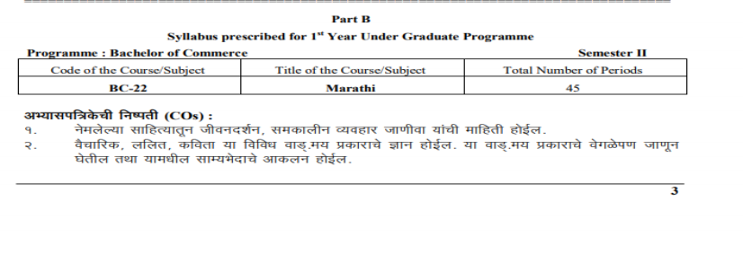

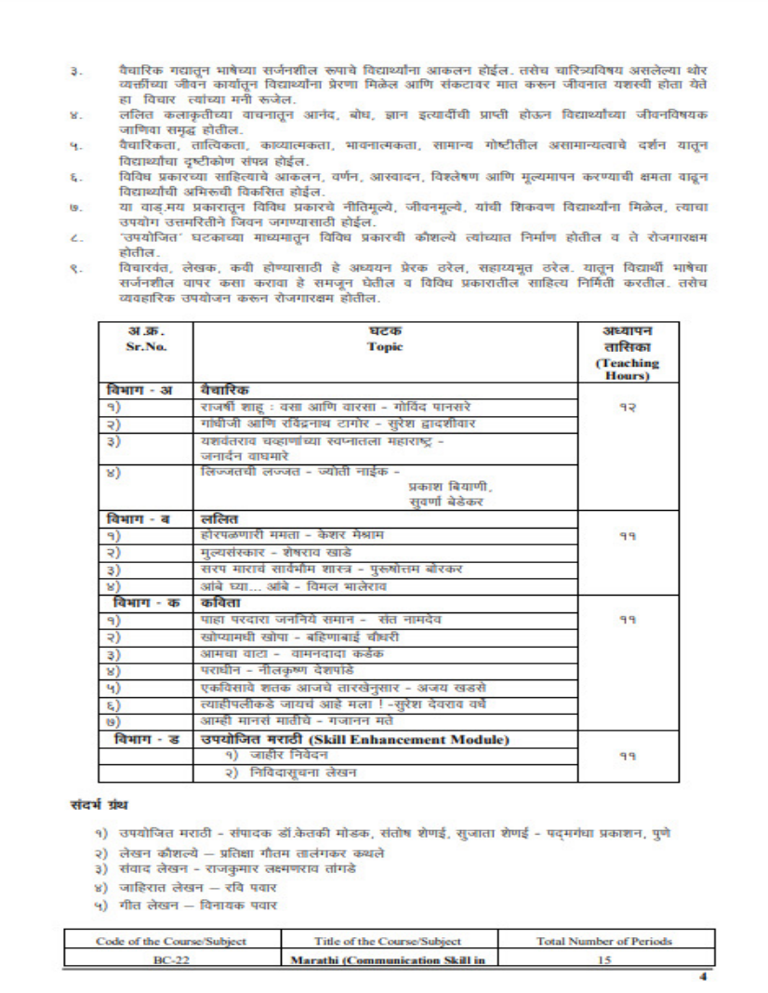

Business Economics (DSC ):BCE:24CO CourseOutcome1 Developafundamentalunderstandingofeconomics,distinguishingbetweenmicroeconomicsandmacroeconomics,andrecognizingeconomicsystemsand basic concepts. 2 Analyzemicroeconomicprinciples,includingconsumerbehavior,elasticityofdemandandsupply,productionandcostanalysis,andmarketstructures. 3 Evaluatemacroeconomicconcepts,suchasnationalincomeandGDP,unemployment,inflation,fiscalandmonetarypolicies,andtheirimplicationsfor business decision-making. 4 Applyeconomictheoriesandprinciplestoreal-worldbusinessscenarios, examiningeconomicfactorsinstrategicplanning,ethicalconsiderations,andemergin

Programme: Bachelor of Commerce (Semester III) Code of Course: Subject Title of Course: Subject Total No. of PeriodsB.C.33 Company Accounts 75Course Outcomes: After going through the subject Company Accounts, the students will be able to: 1. Understand the process with its legal requirements for issuing, forfeiting, and re-issuing equity shares. Apply the relevant accounting treatments and procedures for recording these transactions. 2. Comprehend the format and requirements of Schedule VI Part I & II of the Companies Act 2013 for preparing the final accounts and financial statements of a company. Also, prepare the final accounts and financial statements of a company in accordance with the prescribed schedule and guidelines. 3. Understand the concept and accounting treatment for profit earned before the incorporation of a company and apply the appropriate methods for calculating and disclosing profit prior to incorporation in the financial statements. 4. Gain knowledge of the concept of amalgamation and the different types of amalgamation. Understand the accounting treatment for amalgamation, including the preparation of amalgamation accounts and the treatment of assets, liabilities, and reserves.5. Comprehend legally the concept of absorption and accounting aspects involved in the absorption of a company. Apply the relevant accounting procedures and treatments for recording the absorption of a

Programme: Bachelor of Commerce in Accounting & Finance (Semester III) Code of Course: Subject Title of Course: Subject Total No. of Periods BAF 31 Financial Accounts-III 75Course Outcomes: After going through the subject Financial Accounting-III, the student will be able to: 1. Understand the concept and significance of Bank Reconciliation Statement. 2. Identify the causes of differences between the cash book and pass book in bank reconciliation. 3. Develop the skills to prepare different types of Bank Reconciliation statements. 4. Gain knowledge about the accounting practices for local self-government institutions such as Gram Panchayats. 5. Comprehend the sources of revenues for Gram Panchayats and understand the main features of their accounting. 6. Understand the accounting procedures for Panchayat Samiti and Zila Parishad. 7. Gain knowledge about the accounting practices for local self-government institutions in urban areas and their final accounts. 8. Acquire knowledge about branch accounts and their accounting procedures. 9. Develop an understanding of accounting practices specific to agriculture farms. 10. Gain knowledge about the preparation of final accounts for banking companies. 11. Understand the accounting procedures for insurance companies.

Programme: Bachelor of Commerce (Accounting and Finance) (Semester IV) Code of the course Title of the course / Subject Total no. of periods BAF 4545Computerized Accounting Course outcomes 1. Students will be able to – Familiarized with basics of computerized Accounting 2. Understand utilization of Computerized Accounting Package for Businesses 3. Actual practice with Tally Software

Programme: Bachelor of Commerce in Accounting & Finance (Semester IV) Code of the Course/Subject Title of the Course/Subject (Total Number of Periods BAF 43 Business Statistics 75Course Outcomes: This course aims to equip students with a solid foundation in statistical concepts and data analysis techniques. Students will develop the skills to organize, summarize, and interpret data effectively, as well as apply statistical measures to draw meaningful conclusions and make informed decisions based on data. Upon successful completion of the "Introduction to Statistics and Data Analysis" course, students will be able to: 1. Differentiate between Descriptive Statistics and Inferential Statistics. Identify various types of data (qualitative and quantitative) and their characteristics. Demonstrate knowledge of methods for data collection, tabulation, and presentation. 2. Construct frequency distributions for given datasets to represent data in an organized manner. Apply central tendency measures (mean, median, and mode) to summarize and interpret data distributions. Comprehend the concept of index numbers and construct index numbers for various purposes. 3. Understand the concept of dispersion and its importance in describing data variability. Compute absolute measures of dispersion (e.g., range) and relative measures (e.g., coefficient of variation). Interpret dispersion measures to assess the spread of data. 4. Define skewness and its significance in data distribution. Identify positively skewed, negatively skewed, and symmetric distributions. Calculate and interpret skewness measures to understand the shape of data distribution. 5. Understand the concept of correlation and its relevance in studying relationships between variables. Apply Karl Pearson's formula to calculate the coefficient of correlation for given datasets. Calculate correlation coefficients for both grouped and ungrouped data to analyse associations. 6. Define probable error as a measure of precision in statistical estimates. Calculate probable error to

Programme: Bachelor of Commerce in Accounting & Finance (Semester IV) Code of the Course/Subject Title of the Course/Subject (Total Number of Periods)BAF 41 Management Accounting 75 Course Outcomes: This course aims to equip students with a comprehensive understanding of Management Accounting principles, financial analysis techniques, and their practical applications in managerial decision-making. Students will develop the skills to analyse financial data, interpret results, and make informed decisions to drive the financial success of organizations. Upon successful completion of the "Management Accounting and Financial Analysis" course, students will be able to: 1. 2. 3. 4. 5. 6. 7. Define and explain the meaning and scope of Management Accounting. Identify the importance and limitations of Management Accounting in decision-making. Recognize the role of Management Accounting in supporting managerial decision-making processes. Identify and apply various tools and techniques used in Management Accounting. Evaluate the advantages and limitations of different management accounting techniques. Demonstrate proficiency in using tools for data analysis and performance evaluation. Calculate and interpret key financial ratios to evaluate a company's financial performance. Analyze liquidity, profitability, efficiency, and solvency ratios to assess a company's financial health. Utilize ratio analysis to make informed decisions and recommendations for improvement. Define the Break-Even Point and its significance in business operations. Evaluate the features, advantages, and limitations of Break-Even Analysis. Calculate and interpret Marginal Cost, Contribution, Profit-Volume Ratio, and Margin of Safety. Understand the meaning and importance of variance analysis in cost control. Identify different types of variances, including material, labor, and overhead variances. Apply variance analysis to assess deviations from budgeted figures and suggest corrective actions. Analyze cash flow statements in accordance with Accounting Standard (AS-3). Assess a company's cash inflows and outflows to understand its liquidity position. Interpret cash flow analysis to evaluate the company's ability to meet financial obligations and invest in future growth. Integrate the knowledge gained to analyze and solve practical business problems. Make sound managerial decisions based on financial analysis and management accounting principles. Provide

Code of the Course/Subject Title of the Course/Subject Total Number of PeriodsB.C.-37 Information Technology & Business Data Processing-I 45 Course Outcomes: The students will be able to – 1. Get information about usage of data and how to process the data. 2. Know about DBMS and data warehousing. 3. Become aware about different types of data processing. 4. Know about Spreadsheet Package and its components with formatting. 5. Prepare formulas, functions and charts with complete formatting and page setting.

Programme: Bachelor of Commerce(Semester III) Subject code Title of the subject Total No. ofperiods B.C.-36 Indian Monetary System 75 Course Outcome:

1. Tounderstandthe structure & function of Indian Monetary System.

2. Toenablestudentstounderstandthefunctions,importanceandkindsofmoney.

3. ApplicationofMoneyMarket.

4. To underset and the Inflation and Deflation targeting with special reference to India.

5. TounderstandtheEffectsofDemonetizationonvarioussectorsinIndianeconomy.

Compulsory English - 50 Marks B.Com.II- Sem.III Title of the book- Pristine - By Board of Editors and Published by Orient Black Swan Code of the Course/Subject Title of the Course/Subject Total number of Periods BC 31 English 36 CO’s:

1) To acquaint with the eminent entrepreneurs of the world

2) To acquaint with the work culture in corporate world

3) To in still moral values among the students

4) To make them able to communicate skill fully with ICT

5) To enrich them with fluency and soft skill based in English

6) To make them skill ful in drafting and professional skills.

Syllabus prescribed for 2nd Year Under Graduate Programme Programme: Bachelor of Commerce Semester: III Code of the Subject Title of the Course\Subject Total Number of